Neustar IP Intelligence File Upload in PRM
DOCUMENT OF UNDERSTANDING
Kapil Gaikwad
December 15, 2024
Version: 1.0

Table of Contents
1. Introduction 3
1.1 Restriction on disclosure 3
1.2 Purpose 3
1.3 Document Control 3
1.3.1 Change History 3
2. Proposed solution scope 4
2.1 Proposed CSM Descriptions 4
2.1.1 SFTP Utility 4
2.1.2 Decompression Utility 6
2.1.3 File Splitting Utility 7
2.1.4 Database Upload Utility 9
2.2 Work Flow 13
2.3 Proposed Hardware 17
2.4 Volume Consideration 17
3. aci project considerations 18
3.1 Risks 18
3.2 Recommendations 18
3.3 Assumptions 18

Introduction

Restriction on disclosure
The information (data) contained in this document constitute confidential information and is provided for evaluation purposes only. In consideration of receipt of this document, the recipient agrees to maintain such information in confidence. The disclosure of which may provide competitive advantage to others. This document shall not be disclosed, used or duplicated, in whole or in part, for any other purpose.

Purpose
This document outlines the process of uploading data into the PRM database, which will contain IPv4, IPv6 and IP Reputation data provided by Neustar.

Document Control
A description of the document revisions is shown below.

Change History
Name | Date | Version | Description of Changes
Kapil Gaikwad | 15-Jan-24 | 1.0 | Initial version

Proposed solution scope

Proposed CSM Descriptions
The automation solution for Neustar IP Intelligence data extraction and upload would include the below core functionalities:
- Secured File transfer Utility
- Decompression Utility
- File Splitter Utility
- DB Upload Utility

SFTP Utility
- As part of Neustar IP Intelligence File upload, three files will be provided by the Neustar on weekly basis. Neustar will place the three files IPV4, IPV6 and IP reputation (IPR) to Bank’s SFTP single location in specific file name format having date in “YYYYMMDD” format. The files will be clear files without encryption. The files will carry full dump of data and will be with gz compression. Below are the file naming convention for the files:
  - IPv4 file : customer_id_v942_20190516.csv.gz
  - IPv6 file : customer_id_IPv6_v498_20190514.csv.gz
  - IP reputation file : Needs to confirm with bank team

- SFTP pull program java utility would be developed to copy the files from SFTP location to decompression utilities input folder. This program will be triggered via shell script on startup and it will be always running on NRT AG server. The application configuration will be stored in a properties file which will contain the following parameters:
Config Parameter | Description | Unit
SFTP.connection.host | Specifies the host address for SFTP. | -
SFTP.connection.port | Specifies the connection port for SFTP. | -
SFTP.file.path | Specifies the source directory path for SFTP Operations. | -
SFTP.file.extension | Specifies the file extension used for files during SFTP. | -
SFTP.destination.file.path | Defines the destination path for SFTP Operations. | -
day.parameter | Determines the specific days for which files will be pulled.  0 - Pull for the current day  1 - Pull for current day - 1 | Day
polling.frequency | Defines the time interval between polling attempts. | Minutes
retry.attempts | Defines maximum number of retry attempts allowed. | Number
original.file.prefix | Defines the prefix or initial characters used in naming convention of original files. | -
done.file.prefix | Defines the prefix or initial characters used in naming convention of files marked as completed or processed. | -
err.file.prefix | Defines the prefix or initial characters used in naming convention of files that encountered errors during processing. | -
temp.file.prefix | Defines the prefix or initial characters used in naming convention of temporary files generated during processing in output folder. | -
new.file.prefix | Defines the prefix or initial characters that the utility looks when pulling newly generated files. | -
authentication.type | Determines the authentication method used for access. | -
encrypted.key.password | Determines the password which will be used for authentication. (To encrypt password , CSM password encrypter utility will be used) | -
file.name.date.format | Determines the date format for dates within the filenames. | -

- SFTP pull program will not pull the file if a file is available with same naming convention at destination folder (decompression utilities input folder). It will check for the following prefixes in the output folder:
  - ‘new_’
  - ‘done_’
  - ‘err_’
  - ‘temp_’
- The file is provided with date in the suffix. The date will be used as differentiator. The date format is YYYYMMDD and it would be configurable in configuration file.
- Bank will provide prefix that will be used for identify the file. Also, bank will have to inform if there is change in the prefix, as the config file will have to be modified for the prefix value, to apply the changes, utility needs to be restarted.
- SFTP program will pull the file from SFTP location which is having ‘original.file.prefix’ configured and depending on the specified ‘day’ parameter, it will copy files with name reflecting a date before configured days from current date into the decompression utilities input folder. While copying the file, prefix of output file will be ‘temp_’ in destination folder. Once file copy completed then, output file prefix will be renamed from ‘temp_’ to ‘new_’. No changes would be done for file copied from source location. The output folder for SFTP utility will be input folder for file decompression utility.
- If the SFTP location contains multiple files during the pulling process, each file will be processed sequentially. Upon completion of processing for each respective file, it will be renamed with the file prefix 'new_' in output folder.
- If the SFTP process fails, the IP intelligence file will be retried based on the Config Parameter with consecutive retries specified in the configuration file, once the retry count reaches its limit, an appropriate message will be logged in the audit logs.
- During a retry attempt, the utility deletes the old file created with ‘temp_’ prefix before re-creation, upon successful processing the file prefix changes to 'new_'. If unsuccessful after maximum configurable retries, the file prefix becomes ‘err_’ in the output folder, while the prefix in the input folder remains unchanged. When checking for files with prefix ‘err_’, the utility refrains from initiating a request for such files and proceeds to process the next one.
- In case there is a failure in the SFTP process or seeing any error in the error logs, the PCS team will have to analyse and check for respective error and re-process the file in SFTP utility.
- To manually process a file, the PCS team must rectify errors within the respective file and delete it from the output folder with the prefix 'err_', this action triggers the initiation of the file processing once again. In this cases if the file needs to pulled quickly and does not want to wait till next pulling interval and PCS team will have to restart the respective SFTP utility so that processing will start immediately.
- During the pulling process, if the utility identifies multiple files of the same type, such as IPv4, IPv6 or IP Reputation, it checks the dates in the file names and processes them in ascending order to prevent data loss and ensure retrieval of the latest data.
- Activity/Audit/Error logs would be generated by SFTP batch.

Decompression Utility
- A Java batch decompression utility would be developed which be constantly running on NRT AG server which will periodically check for the input folder for the files with prefix ‘new_’. The application configuration will be stored in a properties file which will contain the following parameters:
Config Parameter | Description | Unit
decompression.input.file.path | Specifies the file path or directory location where compressed input files are stored, awaiting decompression | -
decompression.output.file.path | Specifies the file path or directory location where decompressed output files will be stored. | -
decompression.file.prefix | Defines the prefix or initial characters used in naming convention of files in input folder of decompression’s utility. | -
decompression.file.extension | Specifies the file extension used for files during decompression. | -
polling.frequency | Defines the time interval between polling attempts. | Minutes
retry.attempts | Defines maximum number of retry attempts allowed. | Number
done.file.prefix | Defines the prefix or initial characters used in naming convention of files marked as completed or processed in input folder. | -
err.file.prefix | Defines the prefix or initial characters used in naming convention of files that encountered errors during processing. | -
temp.file.prefix | Defines the prefix or initial characters used in naming convention of temporary files generated during processing in output folder. | -
new.file.prefix | Defines the prefix or initial characters that the utility looks when pulling newly generated files. | -
- Decompression pull program will not pull the file if a file is available with same naming convention at destination folder (File splitting utilities input folder). It will check for the following prefixes in the output folder:
  - ‘new_’
  - ‘done_’
  - ‘err_’
  - ‘temp_’
- If decompression utility program retrieves a single file from the input folder with a 'new_' prefix then it will initiates the decompression process into the output folder. During decompression, the output file is prefixed with 'temp_' in the destination folder. Once the decompression is finished, the output file's prefix is changed from 'temp_' to 'new_', and the prefix of the input file in the input folder is updated to 'done_'. The output folder for decompression utility will be input folder for file splitting utility.
- If the decompression’s input folder contains multiple files during the pulling process, each file will be processed sequentially. Upon completion of processing for each respective file, it will be renamed with the file prefix 'new_' in output folder and the prefix of the input file in the input folder is updated to 'done_'.
- If the decompression process fails, the IP intelligence file will be retried based on the config parameter with consecutive retries specified in the configuration file, once the retry count reaches its limit, an appropriate message will be logged in the audit logs.
- During a retry attempt, the utility deletes the old file created with ‘temp_’ prefix before re-creation, upon successful processing, the file prefix changes to 'new_' in output folder. If unsuccessful after configurable retries, the file prefix becomes ‘err_’ in the output folder, while the prefix in the input folder remains unchanged. When checking for files with prefix ‘err_’, the utility refrains from initiating a request for such files and proceeds to process the next one.
- In case there is a failure in the decompression process, the PCS team will resolve the decompression error and re-process the file. To manually process a file, the PCS team must rectify errors within the respective file and delete the file from the output folder with the prefix ‘err_’, this action triggers the initiation of the file processing once again. In this cases if the file needs to pulled quickly and does not want to wait till next pulling interval and PCS team will have to restart the respective utility so that processing will start immediately.
- During the decompression process, if the utility identifies multiple files of the same type, such as IPv4, IPv6 or IP Reputation, it checks the dates in the file names and processes them in ascending order to prevent data loss and ensure retrieval of the latest data.
- Activity/Audit/Error logs would be generated by decompression utility.

File Splitting Utility
- A new Java batch File splitting utility would be developed which be constantly running on NRT AG server which will periodically check for the input folder for the files with prefix ‘new_’. The application configuration will be stored in a properties file which will contain the following parameters:
Config Parameter | Description | Unit
splitter.input.file.path | Specifies the file path or directory location where decompressed output files will be stored. | -
splitter.output.file.path | Specifies the file path or directory location where split output files will be stored. | -
splitter.file.prefix | Defines the prefix or initial characters used in naming convention of files in input folder of file splitting utility. | -
splitter.file.extension | Specifies the file extension used for files during split process. | -
polling.frequency | Defines the time interval between polling attempts. | Minutes
retry.attempts | Defines maximum number of retry attempts allowed. | Number
number.of.records.per.file | Defines maximum number of records contained in each data file. | Count
done.file.prefix | Defines the prefix or initial characters used in naming convention of files marked as completed or processed input folder. | -
err.file.prefix | Defines the prefix or initial characters used in naming convention of files that encountered errors during processing. | -
temp.file.prefix | Defines the prefix or initial characters used in naming convention of temporary files generated during processing in output folder. | -
temp.done.file.prefix | Defines the prefix or initial characters used in naming convention of file indicate successful processing completion, while waiting for remaining files to be processed. | -
new.file.prefix | Defines the prefix or initial characters that the utility looks when pulling newly generated files. | -

- Splitting utility pull program will not pull the file if a file is available with same naming convention at destination folder (DB upload utilities input folder). It will check for the following prefixes in the output folder:
  - ‘new_’
  - ‘done_’
  - ‘err_’
  - ‘temp_’
  - ‘temp_done_’
- The configuration file will allow the user to configure the number of records per file. The file splitting process will depend on the specified records per file in the configuration. Based on this configuration, files will be generated and stored in the output folder with prefix 'new_’ and names like 'new_<filename>_n.<extension>’ Incrementing the number of each new file.
- If splitting utility program retrieves single file from the input folder with a 'new_' prefix then it will initiates the splitting process into the output folder if the number of records exceeds the configured limit specified in the config file for each file. During the process, the output files are prefixed with 'temp_<filename>_n.<extension>' in the destination folder. Once the splitting process is finished, the output file's prefix is changed from 'temp_<filename>_n.<extension>' to 'new<filename>_n.<extension>', and the prefix of the input file in the input folder is updated to 'done_'. The output folder for the splitting utility will serve as the input folder for the file database upload utility.
- If the splitting utilities input folder contains multiple files, such as IPV4, IPV6, and IP reputation. For e.g. if the process begins with the IPV4 file, the decompressed file records exceed the configured record count, multiple files will be generated during the splitting process. The prefix of each file will be 'temp_<filename>_n.<extension>' while writing into the file. Upon completion of processing for each respective file, it will be renamed with the file prefix 'temp_done_<filename>_n.<extension>'. This step is repeated for all the remaining files at the input location, ensuring each file type undergoes the same process sequentially. Once all files are successfully processed for each file type, their name prefixes will be changed from 'temp_done<filename>_n.<extension>' to 'new<filename>_n.<extension>' to prepare them for the File DB Upload Utility. Additionally, the input files in the input folder are updated with the 'done_' prefix.
- Each split file will begin with a header at the beginning.
- If the splitting process fails for file, the entire process will be retried based on the config parameter with consecutive retries specified in the configuration file to overcome possibility of data corruption in subsequent files, once the retry count reaches its limit, an appropriate message will be logged in the audit logs.
- During a retry attempt, the utility deletes the old file created with ‘temp_’ or ‘temp_done’ prefixes before re-creation, upon successful processing the file prefix changes to 'new_' in output folder. If unsuccessful after retries, the file prefix becomes ‘err_’ in the output folder, while the prefix in the input folder remains unchanged. When checking for files with prefixes ‘err_’, the utility refrains from initiating a request for such files and proceeds to process the next one.
- In case there is a failure in the splitting process, the PCS team will resolve the splitting error and re-process the file. To manually process a file, the PCS team must rectify errors within the respective file and delete it from the output folder with the prefixes ‘err_’ and ‘temp_done’, this action triggers the initiation of the file processing once again. In this cases if the file needs to pulled quickly and does not want to wait till next pulling interval and PCS team will have to restart the respective utility so that processing will start immediately.
- During the splitting process, if the utility identifies multiple files of the same type, such as IPv4, IPv6 or IP Reputation, it checks the dates in the file names and processes them in ascending order to prevent data loss and ensure retrieval of the latest data.
- Activity/Audit/Error logs would be generated by file splitting utility.

Database Upload Utility
- A Java batch DB Upload Utility would be developed which be constantly running on NRT AG server which will periodically check for the input folder for the files with prefix 'new_'. The application configuration will be stored in a properties file which will contain the following parameters:
Config Parameter | Description | Unit
database.connection.username | Specifies the username for database, | -
database.connection.password | Specifies the password for database in encrypted format. (To encrypt password , CSM password encrypter utility will be used) | -
database.connection.url | Specifies the URL that defines the location of the database for establishing connection. | -
database.connection.driver | Specifies the JDBC driver class used for connecting to the database. | -
database.table.names | Specifies the names of the database tables involved in the process | -
database.flag.column.name | Specifies the name of the column in the database table used as flag to indicate certain conditions or states. | -
dbUpload.input.file.path | Specifies the file path or directory location where split output files will be stored. | -
dbUpload.output.file.path | Specifies the file path or directory location where processed files of database upload are stored. | -
dbUpload.file.prefix | Defines the prefix or initial characters used in naming convention of files in input folder of DB Upload utility. | -
dbUpload.file.extension | Specifies the file extension used for files during split process. | -
polling.frequency | Defines the time interval between polling attempts. | Minutes
done.file.prefix | Defines the prefix or initial characters used in naming convention of files marked as completed or processed in output folder. | -
err.file.prefix | Defines the prefix or initial characters used in naming convention of files that encountered errors during processing. | -
temp.file.prefix | Defines the prefix or initial characters used in naming convention of temporary files generated during processing in output folder. | -
temp.done.file.prefix | Defines the prefix or initial characters used in naming convention of file indicate successful processing completion, while waiting for remaining files to be processed. | -
new.file.prefix | Defines the prefix or initial characters that the utility looks when pulling newly generated files. | -

- DB Upload utility pull program will not pull the file if a file is available with same naming convention at destination folder (DB upload utilities output folder). It will check for the following prefixes in the output folder:
  - ‘done_’
  - ‘err_’
  - ‘temp_’
  - ‘temp_done_’
- If DB Upload utility program retrieves single file from the input folder with a 'new_' prefix then it will initiates the upload process into the output folder. During the process, The dummy file will be created with prefix 'temp_<filename>_n.<extension>' in destination folder while uploading into the db. Upon successful processing of file, corresponding file from the input folder will be moved to output folder with 'temp_done<filename>_n.<extension>' prefix and 'temp_<filename>_n.<extension>' will be deleted from the the output folder. Once all processing including upload operation, switching flag for the file is successful ,then output folder prefix for that file will be changed to 'done_<filename>_n.<extension>' from 'temp_done<filename>_n.<extension>' .
- If the DB Upload utility's input folder contains multiple splitted files, such as IPV4, IPV6, and IP reputation, for e.g. if the process begins with the IPV4 file. The dummy files will be created with prefix 'temp_<filename>_n.<extension>' in output folder while uploading into the db. Upon completion of processing for each respective file, corresponding file from the input folder will be moved to output folder with 'temp_done<filename>_n.<extension>' prefix and 'temp_<filename>_n.<extension>' will be deleted from the the output folder.This step is repeated for all the remaining files at the input location, ensuring each file type undergoes the same process sequentially. Once all processing including upload operation, switching flag for the particular flle type is successful then output folder prefix for that files will be changed to 'done_<filename>_n.<extension>' from 'temp_done<filename>_n.<extension>' .
- A new table will be introduced as IP_INTEL_SWITCH_TABLE with six entries: SBI_IPV4_1, SBI_IPV4_2, SBI_IPV6_1, SBI_IPV6_2, SBI_IP_REPUTATION_1 and SBI_IP_REPUTATION_2. Each entry will have a corresponding flag. For instance, if the table type is IPV4, one entry's flag will be 1, and another entry's flag will be 2, and so on for each respective type.
- A new table (NEUSTAR_FILE_UPLOAD_STATISTICS) will be introduced to track the status of files , indicating whether they are split or single file. Once a file is splitted or enters the database uploads input folder, its status is updated in this table as "initiated for DB upload." Each split file has a separate entry in the table. Upon successful upload, the respective file's status is changed to "success," and in case of an error, it is updated to "failed."
- The utility checks this table for the 'ip_intelligence' file. Before uploading data into the ip_intelligence table, it will check for a flag in IP_INTEL_SWITCH_TABLE where the flag = 2. If found, utility will delete records from the table and then initiates the upload process. Files with a status of success are uploaded into the database where IP_INTEL_SWITCH_TABLE flag = 2. If all files of the same type and date have a status of success, the utility interchanges the flag values in the IP_INTEL_SWITCH_TABLE from 2 to 1 for same type.
- If the DB upload utility fails to process any file, that particular file will be skipped and all records inserted into DB for respective file will be roll backed. Utility will change Failed file prefix to ‘err_’ from ‘temp_’ into the output folder while the prefix in the input folder remains unchanged and the status will be updated in statistics table as “failed” for respective file. The processing for failed file upload to be taken care by PCS team manually.
- To manually process the file PCS team is required to address the errors in the ‘err_’ file and delete it from the output folder with the prefixes ‘err_’, this action triggers the initiation of the file processing once again. In this cases if the file needs to pulled quickly and does not want to wait till next pulling interval and PCS team will have to restart the respective utility so that processing will start immediately.
- During the upload process, if the utility identifies multiple files of the same type, such as IPv4, IPv6 or IP Reputation, it checks the dates in the file names and processes them in ascending order to prevent data loss and ensure retrieval of the latest data.
- The DB Upload utility would read config file to determine the DB string, DB Credentials (Encrypted), upload table names & switch table names.
- Activity/Audit/Error logs would be generated by DB upload batch.
- Any errors will be logged in the audit log file and in SYSTEMAUDIT Table.

Work Flow
Architecture of Neustar IP Intelligence File Upload in PRM.

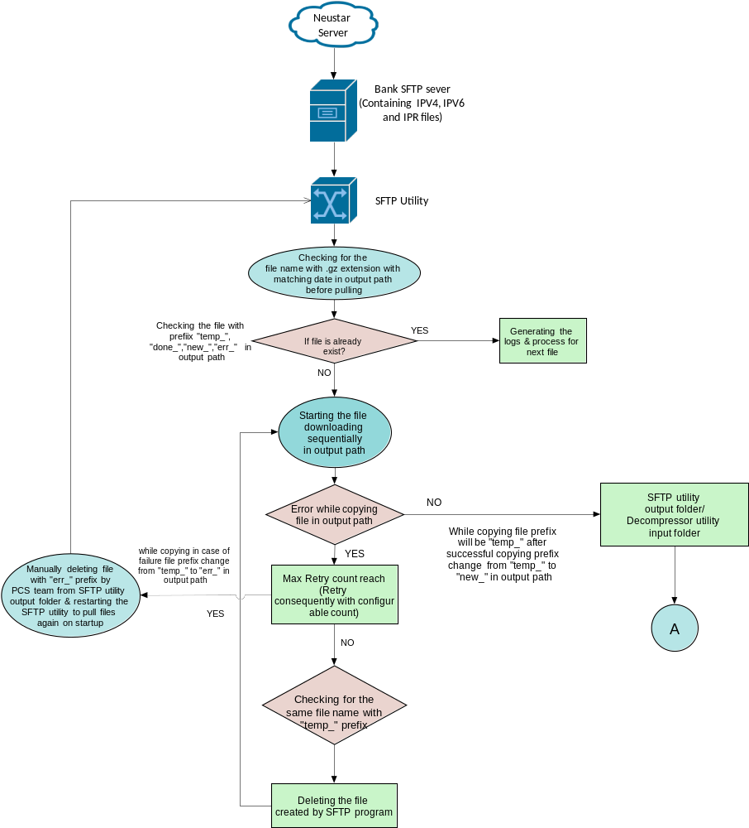

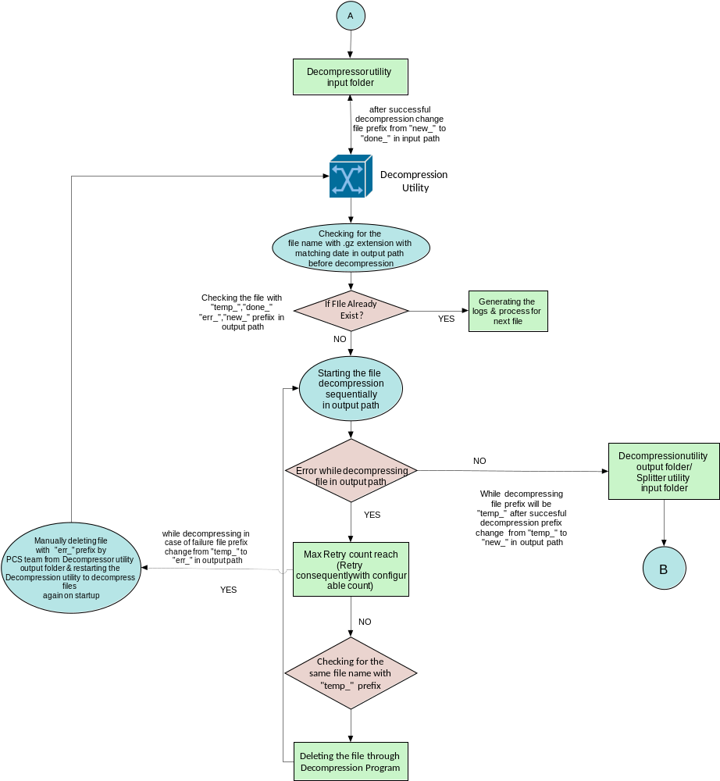

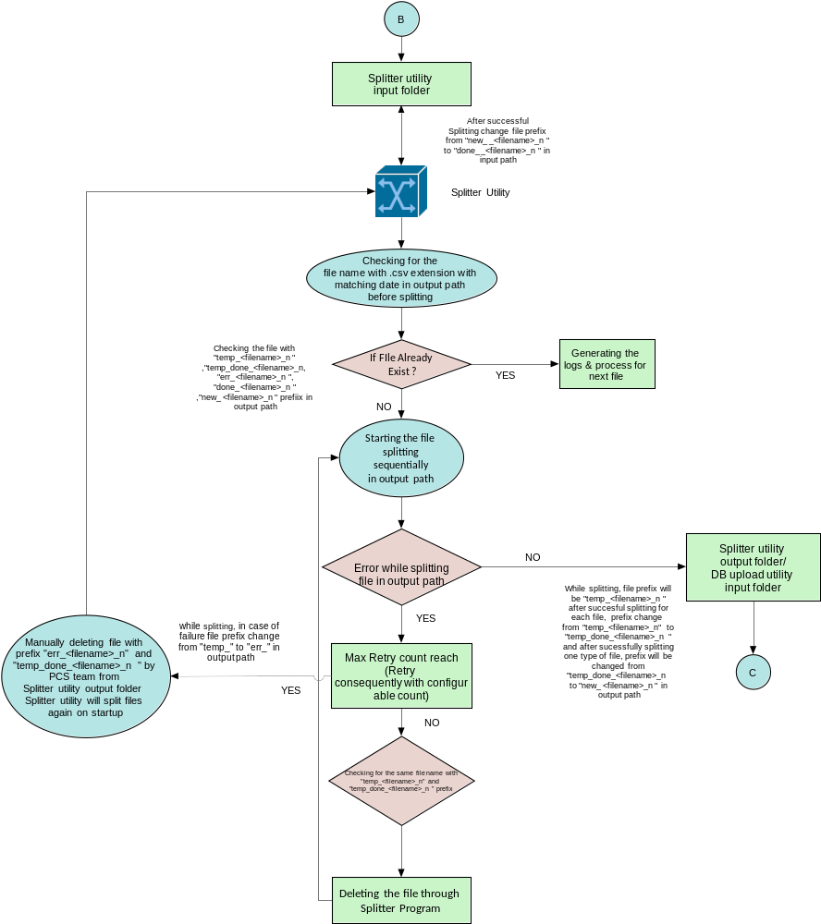

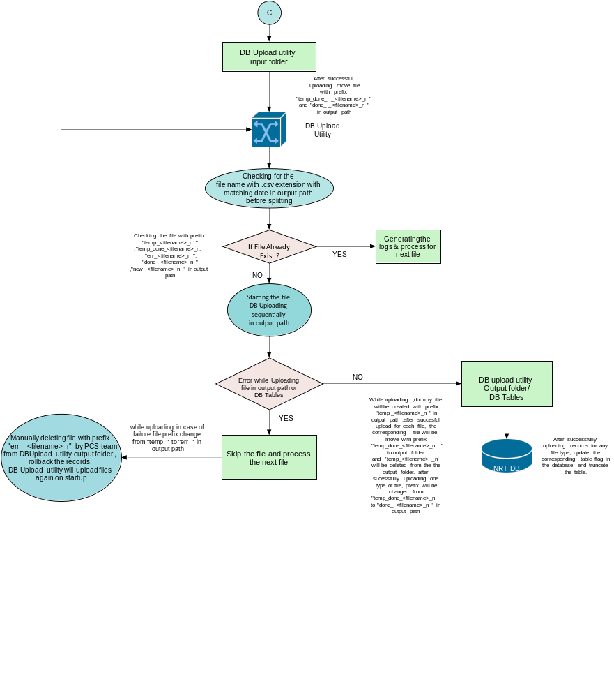

Proposed Hardware
PRM application version | PRM 9.2.4 (PRM Web UI)
Application server | Linux RHEL 9.1
UI server | IBM WebSphere 9.0.5.13
Database | Oracle 19C (exadata)
Java Version | JAVA 8

Volume Consideration
- IPv4 :
  - 65GB decompressed (3.5GB compressed)
  - ~120 to 165 million records (rows/ranges of IPs)
- IPv6 :
  - 1.7GB decompressed (150MB compressed)
  - ~2.4 million records
- IP Reputation :
  - 180GB decompressed (? compressed)Bank team to confirm
  - ~3 billion records

aci project considerations

Risks
- There might be a performance impact due to uploading 500+ Million records to PRM Database, Hence, it’s necessary to ensure adequate infrastructure resource are made available.

Recommendations
- Ensure sufficient storage capacity to facilitate smooth decompression and splitting processes promoting error-free batch flow.

Assumptions
- SFTP will work on password basis and bank will provide the SFTP credential for same.
- Bank to provide access to database and login credentials to execute file upload stored procedures.
- Bank would ensure adequate infrastructure is available to process the 500+ million records without affecting existing online transaction processing from other channels.
- All 3 type of files to be available at SFTP location on the same day/time.
- Each compressed .gz file should contain either an IPv4, IPv6 or IP reputation file, for each file type separate compressed file is expected at single SFTP location.
- Header column sequence would remain same in files over the period of time.
- 10 days Auto-purging is set on SFTP folder from bank side.
- To implement changes in the configuration of the respective utility, it is necessary to restart the utility.
- If 2 out of 3 files type (i.e. IPV4, IPV6, IPR) are processed successfully and 1 file type encountered with an error, then processing flow of the two successfully processed file types will be proceeded further.
- For multiple files for single file type (e.g., IPV4_1, IPV4_2, IPV4_3) if 2 out of 3 files type processed successfully and 1 encountered with an error, the processing flow of the two successfully processed files will be proceed.
- IPV4, IPV6 and IPR files be located in single folder at SFTP source location and will be available at the same time.
- No restart of the batch to be taken in case any file processing is in progress
- The processing for any failed step needs to be handled manually by the PCS team.
- Manual processing by the PCS team should be completed within the same week to maintain the workflow.
- To facilitate manual processing, the following files from the output folder should be deleted based on respective utilities:
Utility | Files to delete
Secured File transfer Utility (SFTP) | err_
Decompression Utility | err_
File Splitter Utility | err_ , temp_done_
DB Upload Utility | err_

- File purging on PRM server from different input and output folders to be taken care PCS team in automated/manual way.

